1. Write a program to display HelloWorld.

<?xml version="1.0" encoding="utf-8"?>

<androidx.constraintlayout.widget.ConstraintLayout

xmlns:android="http://schemas.android.com/apk/res/android"

xmlns:app="http://schemas.android.com/apk/res-auto"

xmlns:tools="http://schemas.android.com/tools"

android:layout_width="match_parent"

android:layout_height="match_parent"

android:background="#FFC107"

tools:context=".MainActivity">

<TextView

android:layout_width="wrap_content"

android:layout_height="wrap_content"

android:background="#2196F3"

android:text="Hello World!"

android:textColor="#000000"

android:textSize="24sp"

android:textStyle="bold"

android:contentDescription="Hello World Text"

app:layout_constraintTop_toTopOf="parent"

app:layout_constraintBottom_toBottomOf="parent"

app:layout_constraintStart_toStartOf="parent"

app:layout_constraintEnd_toEndOf="parent" />

</androidx.constraintlayout.widget.ConstraintLayout>

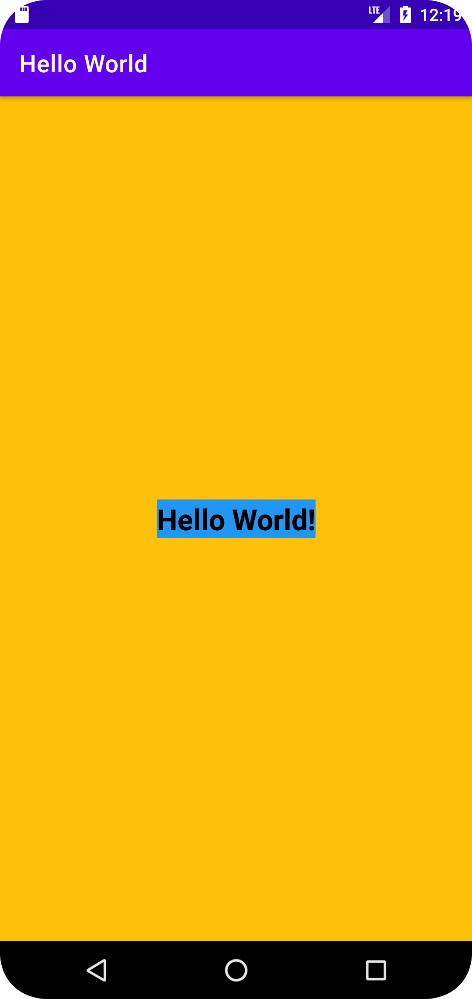

1. Write a program to display student name and marks.

<?xml version="1.0" encoding="utf-8"?>

<TableLayout xmlns:android="http://schemas.android.com/apk/res/android"

android:layout_width="match_parent"

android:layout_height="match_parent"

xmlns:tools="http://schemas.android.com/tools"

android:background="#f6f6f6"

android:padding="10dp"

tools:context=".MainActivity">

<!-- Header Row -->

<TableRow

android:background="#98ded9"

android:padding="5dp">

<TextView

android:layout_width="wrap_content"

android:layout_height="wrap_content"

android:text="Students Information"

android:textColor="#161d6f"

android:textSize="30sp"

android:textStyle="bold"

android:gravity="center"

android:layout_gravity="center_horizontal"/>

</TableRow>

<!-- Student Rows -->

<TableRow android:background="#c7ffd8" android:padding="5dp">

<TextView

android:id="@+id/text1"

android:layout_width="wrap_content"

android:layout_height="wrap_content"

android:text="Name: Meet ; Marks: 96"

android:textColor="#161d6f"

android:textSize="30sp"

android:textStyle="bold" />

</TableRow>

<TableRow android:background="#98ded9" android:padding="5dp">

<TextView

android:id="@+id/text2"

android:layout_width="wrap_content"

android:layout_height="wrap_content"

android:text="Name: Shivam; Marks: 97"

android:textColor="#161d6f"

android:textSize="30sp"

android:textStyle="bold" />

</TableRow>

<TableRow android:background="#c7ffd8" android:padding="5dp">

<TextView

android:id="@+id/text3"

android:layout_width="wrap_content"

android:layout_height="wrap_content"

android:text="Name: Sneha ; Marks: 99"

android:textColor="#161d6f"

android:textSize="30sp"

android:textStyle="bold" />

</TableRow>

<TableRow android:background="#98ded9" android:padding="5dp">

<TextView

android:id="@+id/text4"

android:layout_width="wrap_content"

android:layout_height="wrap_content"

android:text="Name: Shivaji ; Marks: 96"

android:textColor="#161d6f"

android:textSize="30sp"

android:textStyle="bold" />

</TableRow>

<TableRow android:background="#c7ffd8" android:padding="5dp">

<TextView

android:id="@+id/text5"

android:layout_width="wrap_content"

android:layout_height="wrap_content"

android:text="Name: Aashu ; Marks: 97"

android:textColor="#161d6f"

android:textSize="30sp"

android:textStyle="bold" />

</TableRow>

<TableRow android:background="#98ded9" android:padding="5dp">

<TextView

android:id="@+id/text6"

android:layout_width="wrap_content"

android:layout_height="wrap_content"

android:text="Name: Tanvi ; Marks: 92"

android:textColor="#161d6f"

android:textSize="30sp"

android:textStyle="bold" />

</TableRow>

<TableRow android:background="#98ded9" android:padding="5dp">

<TextView

android:id="@+id/text7"

android:layout_width="wrap_content"

android:layout_height="wrap_content"

android:text="Name: Shristi ; Marks: 100"

android:textColor="#161d6f"

android:textSize="30sp"

android:textStyle="bold" />

</TableRow>

</TableLayout>

